# Assignment -1

|  |  |
| --- | --- |
| Assignment Date | 12 October 2022 |
| Student Name | Meghana Siddanthi |
| Student Roll Number | 111619106081 |
| Maximum Marks | 2 Marks |

# Question-1:

Make a Smart Home in Tinkercad, using 2+ sensors, Led, Buzzer in single circuit.

**Solution :**

// C++ code

int trig = 2;

int echo = 3;

int led=4;

int buz=6;

int led1=7;

void setup()

{

Serial.begin(9600);

pinMode(trig,OUTPUT);

pinMode(echo,INPUT);

pinMode(led,OUTPUT);

pinMode(led1,OUTPUT);

pinMode(buz,OUTPUT);

}

void loop() {

// temperature sensor

double t = analogRead(A2);

Serial.print("Analog data: ");

Serial.println(t);

double n= t/1024;

double v=n*5;

Serial.print("Voltage data: ");

Serial.println(v);

double c=v-0.5;

double k=v*100;

Serial.print("Temperature value:");

Serial.println(k);

delay(1000);

//ultasonic sensor

digitalWrite(trig,LOW);

digitalWrite(trig,HIGH);

delayMicroseconds(10);

digitalWrite(trig,LOW);

float dur=pulseIn(echo,HIGH);

float dist=(dur*0.0343)/2;

Serial.print("Distance in cm : ");

Serial.println(dist);

//led if(dist>=100)

{

digitalWrite(led,HIGH);

}

else

{

digitalWrite(led,LOW);

}

//buzzer

digitalWrite(buz,LOW);

digitalWrite(led1,LOW);

delay(1000);

digitalWrite(buz,HIGH);

digitalWrite(led1,HIGH);

delay(1000);

}

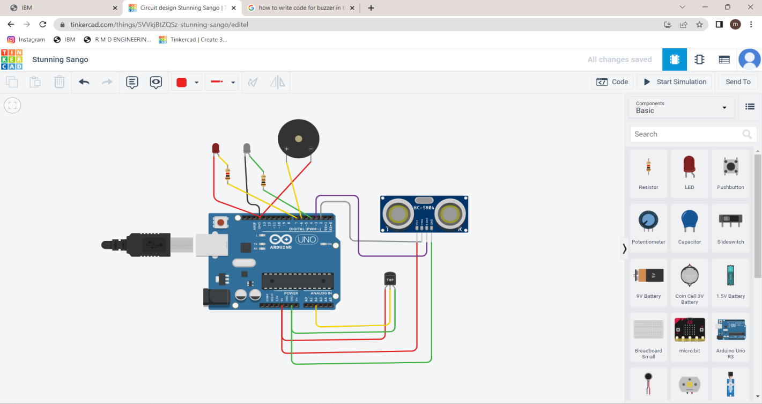

Tinker card link :

https://www.tinkercad.com/things/5VVkjBtZQSz